CAMBRIDGE UNIVERSITY POLO CLUB
SAFETY POLICY

INTRODUCTION
Cambridge University Polo Club (CUPC) is strongly committed to encouraging our members to take part, but the health, well-being and safety of each individual is always our paramount concern.

To support our Health and Safety policy statement we are committed to the following duties:
- Undertake regular, recorded risk assessment of the club premises and all activities undertaken by the club.
- Create a safe environment by putting health and safety measures in place as identified by the assessment.
- Ensure that all members are given the appropriate level of training and competition by regularly assessing individual ability dependant on age, maturity and development.
- Ensure that all members are aware of, understand and follow the club’s health and safety policy.
- Appoint a competent club member to assist with health and safety responsibilities.
- Ensure that normal operating procedures and emergency operating procedures are in place and known by all members.
- Provide access to adequate first aid facilities, telephone and qualified first aider at all times.
- Report any injuries or accidents sustained during any club activity or whilst on the club premises.
- Ensure that the implementation of the policy is reviewed regularly and monitored for effectiveness.

AS A CLUB MEMBER YOU HAVE A DUTY TO:
- Take reasonable care for your own health and safety and that of others who may be affected by what you do or not do.
- Co-operate with the club on health and safety issues.
- Correctly use all equipment provided by the club.
- Not interfere with or misuse anything provided for your health, safety or welfare.

CLUB HEALTH AND SAFETY OFFICER:
Aeisha Johnson, membership@cupoloclub.com
Please report any safety concerns or accidents to our safety officer.

FIRST AID: Location of first aid facilities: First aid box in club house.
Location of telephones: Office in club house.

QUALIFIED FIRST AIDERS: Francis Molyneux (CUPC Head Coach)
Ed Wright (Owner of Cambridge County Polo Club)

APPENDICES:
- Appendix 1 Risk Assessment Form
- Appendix 2 CUPC Member Terms and Conditions
- Appendix 3 Accident Form

Appendix 1: Risk Assessment Form
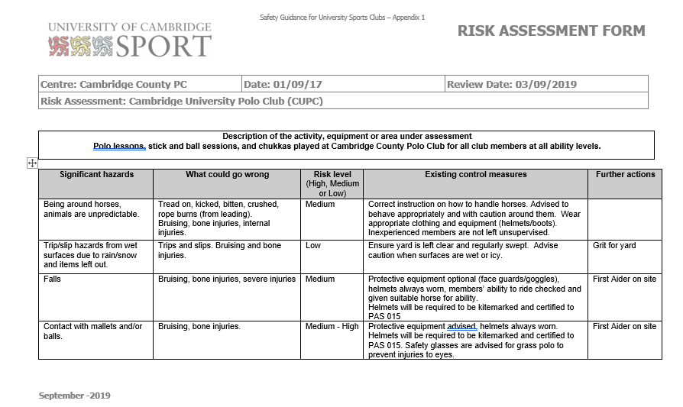

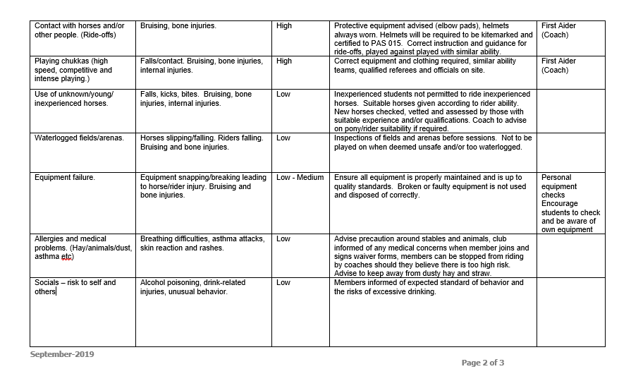

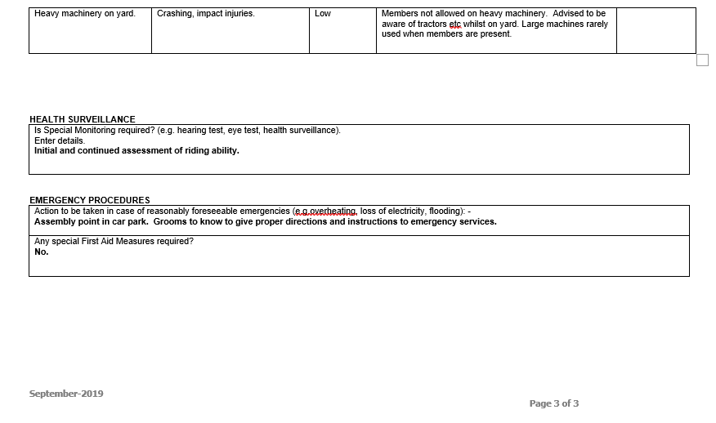

Appendix 2: CUPC Member Terms and Conditions

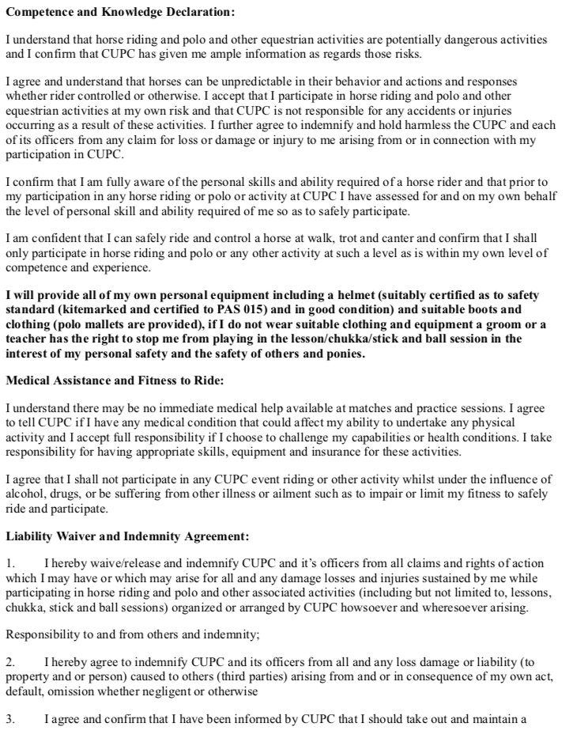

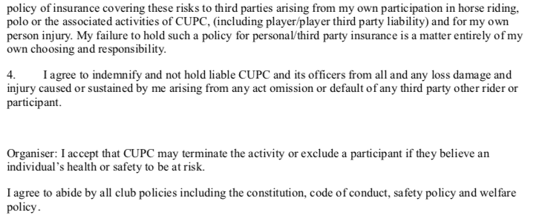

Appendix 3: Accident Form
